Programming 3A

Prog7311

POE Part 3

ST10365374

**1. Optimizing the Prototype's Performance**

During prototype development, performance was prioritized to ensure that the Agri-Energy Connect platform provides a seamless and dependable user experience. Several best practices were implemented to make the system fast and scalable. These procedures can be improved as the platform grows.

**Optimizations in Place:**

* Asynchronous Code: Database queries and user operations use asynchronous programming, which reduces delays and improves speed during busy periods (GeeksforGeeks, 2024).
* Efficient Database Access: Entity Framework Core was used to manage data operations, allowing for cleaner queries and reduced load (Microsoft, 2021).
* Smart Content Handling: Static files (like stylesheets and images) are served efficiently to reduce load times (Rick-Anderson, 2025).
* Simple Caching: Frequently accessed data, such as product lists, can be cached temporarily to avoid repeating database hits (GeeksforGeeks, 2022).

**Final Product Guidelines:**

* Load Testing: Use tools like JMeter to simulate heavy traffic and identify bottlenecks before launch (Apache Software Foundation, 2019).
* Cloud Hosting: Deploy scalable services like Microsoft Azure with auto-scaling features (Microsoft, 2022).
* Minify Assets: JavaScript and CSS files should be compressed to reduce load times especially on mobile devices.
* Database Tuning: Add indexes to commonly searched fields like email, product type, and dates to speed up queries.
* Asynchronous Everything: All long-running tasks like uploads and reports should run asynchronously to avoid freezing the UI (GeeksforGeeks, 2024).
* Use a CDN: Static content can be offloaded to a content delivery network for global reach and faster load times (Cloudflare.com, 2024).

These practices ensure that the platform can handle high traffic, serve users fast, and remain reliable on both desktop and mobile devices.

**2. Recommended Software Development Methodology**

For this kind of project, I would recommend Agile development using the Scrum framework.

### **Why Scrum Works for Agri-Energy Connect:**

* Fast Delivery: Features are delivered in short cycles (called sprints), allowing early access to working versions of the platform (Craddock, 2024).
* Regular Feedback: After each sprint, feedback can be gathered from farmers, employees, or stakeholders to ensure the system meets real-world needs (Craddock, 2024).
* Flexible Planning: Requirements in agriculture and energy can change quickly. Scrum makes it easy to adjust priorities as needed (Craddock, 2024).
* Risk Reduction: Issues are spotted early such as usability problems or performance gaps, and fixed before they grow (Craddock, 2024).

Scrum encourages team collaboration, shared ownership of the project, and constant improvement, making it a great match for the Agri-Energy Connect mission.

**3. Should DevOps Be Implemented?**

I believe that DevOps is highly recommended as it's a practical approach that brings together development and operations to build better and faster software.

**How DevOps Helps This Project?**

* CI/CD Pipelines: Tools like GitHub Actions or Azure DevOps automate testing and deployment after each sprint, helping deliver updates faster (Netapp.com, 2023).
* Collaboration: Developers, testers, and system admins work together seamlessly, reducing delays and improving workflow (Netapp.com, 2023).
* Real-Time Monitoring: Services like Application Insights and Azure Monitor give instant feedback on system performance and user activity (Netapp.com, 2023).
* Quick Rollbacks: If an issue arises in production, the system can easily revert to a stable version without major downtime (Netapp.com, 2023).

**Why It Matches Scrum:**

Scrum and DevOps both emphasize iteration, feedback, and continuous improvement. They work together to build a fluid pipeline from code to client, ensuring that updates are secure, rapid, and valuable. (NetApp.com, 2023)

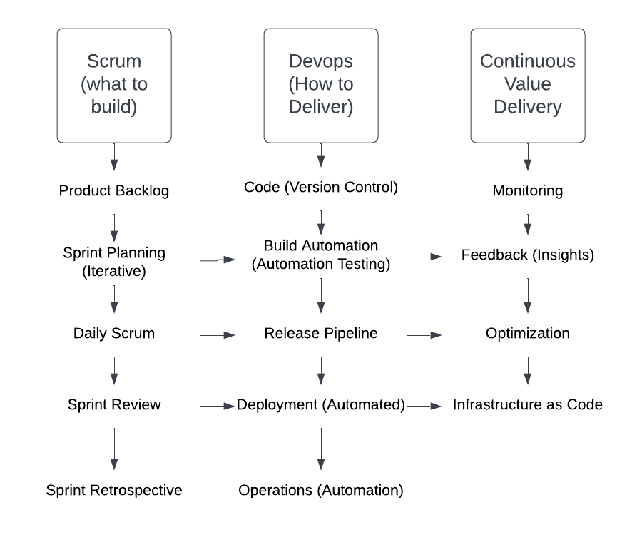(Lucid.app, 2025)

**4. Recommended Architecture Framework**

I would recommend using a mix of TOGAF and the Zachman Framework for the long-term success of Agri-Energy Connect.

**Why TOGAF?**

TOGAF is a widely used framework for designing and managing enterprise systems. It includes a structured method called ADM (Architecture Development Method) and tools to plan, build, and improve complex digital platforms (Visual-paradigm 2024).

**What TOGAF Helps Define?**

* Business Architecture: What the system is meant to deliver to its users and stakeholders (Visual-paradigm, 2024).
* Data Architecture: How information is stored, structured, and shared across the system (Visual-paradigm, 2024).
* Application Architecture: How software components interact and deliver functionality (Visual-paradigm, 2024).
* Technology Architecture: The infrastructure that supports applications such as cloud platforms, services, security (Visual-paradigm, 2024).

**Why TOGAF Works for Agri-Energy Connect?**

* Structured Planning: The ADM cycle guides the system from vision to implementation and ongoing updates (Visual-paradigm 2024).
* Team Alignment: Helps teams stay coordinated using a shared framework for documents and processes (Visual-paradigm 2024).
* Scalability and Reuse: Supports reuse of existing models, speeding up development and scaling (Visual-paradigm 2024).
* Governance Support: Defines roles and tracks maturity to improve architectural decision-making (Visual-paradigm 2024).
* Business and IT Alignment: Keeps the system focused on real goals like sustainability and collaboration (Visual-paradigm 2024).

**Why** **Combine with Zachman?**

The Zachman Framework adds value to TOGAF by helping teams view the system from different stakeholders' perspectives. It uses a 6 by 6 grid that combines roles like planner or user with key questions like what, how, where, who, when and why. This makes sure every part of the system is considered. (Ardoq 2024).

**How Zachman Enhances TOGAF:**

**Broader Perspectives**

While TOGAF focuses on building linear architecture step by step, the Zachman Framework helps teams see the system from different viewpoints like users, IT staff, and managers (Ardoq 2024).

**Complete Coverage**

Zachman’s grid connects roles with key concerns like data, processes, and locations. This makes sure nothing important is overlooked (Ardoq 2024).

**Better Communication**

By creating a shared structure and language, the framework helps teams from different departments understand each other and work together more smoothly (Ardoq 2024).

**Easier Change and Compliance**

It also helps manage change by showing how different parts of the system depend on each other, which supports compliance and reduces risk during updates (Ardoq 2024).

**5. Technical Overview for Marketing Presentation**

**Platform Purpose:**

Agri-Energy Connect is a secure, web based platform that helps farmers and green energy workers collaborate and share resources. The goal is to make sustainable farming easier and more connected.

**Technologies Used:**

|  |  |
| --- | --- |
| **Technologies Used** | **Purpose** |
| ASP.NET Core MVC | The main framework used to build the website. |
| C# | The programming language is used for all server-side logic. |
| SQL Server | A reliable database that stores user information, product data, and more. |
| ASP.NET Identity | Used for secure login and role-based access. |
| Bootstrap | Used responsive design that ensures the site looks good on phones, tablets, and desktops. |

**What Users Can Do:**

|  |  |
| --- | --- |
| **User Roles** | **Key Capabilities** |
| Farmers | * Register and log in securely. * Add agricultural products (with type and date). * View and manage their own product listings. |
| Employees | * Add new farmers to the system. * View all farmer products. * Filter products by type or date range. |

**Visual Overview:**

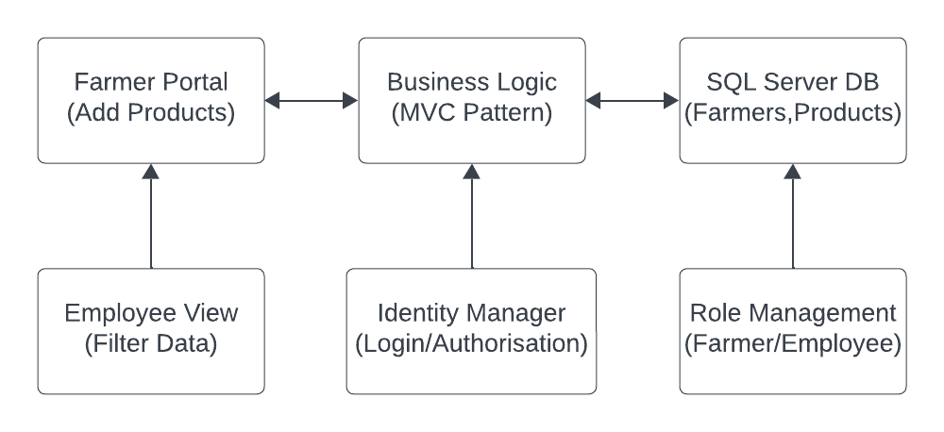  
(Lucid.app, 2025)  
 **This setup ensures the system is:**

1. Secure so that only authenticated users can access their data.
2. Simple to use as it's designed for users with little technical knowledge.
3. Easy to expand so that new features like weather alerts or energy integration can be added later.

**Conclusion**

This report clearly addresses the important themes that will help both technical and business teams shape the future of Agri-Energy Connect. It focuses on performance, current development approaches (Agile + DevOps), architecture planning, and a precise description of the prototype's functionality.

The marketing team can now confidently showcase this solution, knowing that it is not only well built but also aligned with the overall purpose of integrating agricultural with sustainable technology.

**References**

Apache Software Foundation, 2019. *Apache JMeterTM*. [online] Available at: <https://jmeter.apache.org/> [Accessed 20 Jun. 2025].

Ardoq, 2024. *What is the Zachman Framework? A Definitive Guide to this EA Standard*. [online] Available at: <https://www.ardoq.com/knowledge-hub/zachman-framework> [Accessed 20 Jun. 2025].

Cloudflare, 2024. *Why use a CDN? | CDN Benefits*. [online] Available at: <https://www.cloudflare.com/learning/cdn/cdn-benefits/> [Accessed 20 Jun. 2025].

Craddock, A., 2024. *Top 10 Benefits of Scrum and Frequent Challenges*. [online] Available at: <https://apmg-international.com/article/top-10-benefits-scrum-and-frequent-challenges> [Accessed 20 Jun. 2025].

GeeksforGeeks, 2022. *Basic Cache Optimization Techniques*. [online] Available at: <https://www.geeksforgeeks.org/basic-cache-optimization-techniques/> [Accessed 20 Jun. 2025].

GeeksforGeeks, 2024. *Synchronous and Asynchronous Programming*. [online] Available at: <https://www.geeksforgeeks.org/javascript/synchronous-and-asynchronous-programming/> [Accessed 20 Jun. 2025].

Lucid Software, 2025. *Lucid visual collaboration suite*. [online] Available at: <https://lucid.app/lucidchart/92dad740-eb6f-440b-892e-89e5851a9bf9/edit?invitationId=inv_5073850d-81e0-4ad9-b249-e431657176d2&page=0_0> [Accessed 20 Jun. 2025].

Microsoft, 2021. *Overview of Entity Framework Core*. [online] Available at: <https://learn.microsoft.com/en-us/ef/core/> [Accessed 20 Jun. 2025].

Microsoft, 2022. *Autoscaling Guidance - Best Practices for Cloud Applications*. [online] Available at: <https://learn.microsoft.com/en-us/azure/architecture/best-practices/auto-scaling> [Accessed 20 Jun. 2025].

NetApp, 2023. *What is DevOps?*. [online] Available at: <https://www.netapp.com/devops/what-is-devops/> [Accessed 20 Jun. 2025].

Rick-Anderson, 2025. *Static files in ASP.NET Core*. [online] Available at: <https://learn.microsoft.com/en-us/aspnet/core/fundamentals/static-files?view=aspnetcore-9.0> [Accessed 20 Jun. 2025].

Visual Paradigm, n.d. *TOGAF 9.1 Framework - A Comprehensive Guide*. [online] Available at: <https://www.visual-paradigm.com/guide/togaf/togaf-91-framework/> [Accessed 20 Jun. 2025].

‌

‌